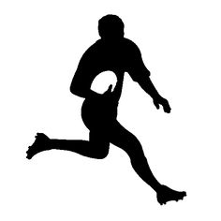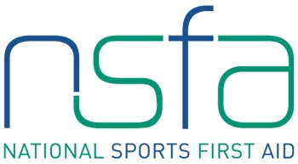

SPORTS FIRST AID

**2-DAY INTENSIVE COURSE**

**MON/TUES 8th & 9th SEPTEMBER 2014**

(Time: 9am – 4pm BOTH DAYS)

**HELD AT:** British Legion Hall,

Huntly Street, Inverness, IV3 5PR

**COST £160.00**

The National Sports First Aid course is delivered over the two full days. Particular attention is paid throughout the course to applying the information and skills to specific sports specific situations as well as general life. This will incorporate real life scenarios and experiences with lots of practical hands-on skills as well as gaining vital information.

Two-way discussion and questions are encouraged throughout the course and inclusion of the tutor's and students' own previous practical experiences will add to the learning experience.

* A specialist, 2 day assessed course recognised by: Association of First Aiders, Scottish FA, Sport Scotland, Scottish Institute of Sport, FSEM and the Commonwealth Games Council for Sport amongst others.
* Offers a nationally recognised qualification in Sports First Aid in the UK.
* On successful completion of the course and assessment a certificate will be awarded by NSFA and the person is then added to the NSFA database as a Certified Sports First Aider.

**The National Sports First Aid certificate is valid for three years**

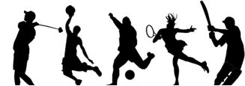

**For more information or to book a place**

Please Contact: Vince Walker (Tutor)

Tel: 01593 721577 / 07717 681823

Email: vwincey@btinternet.com