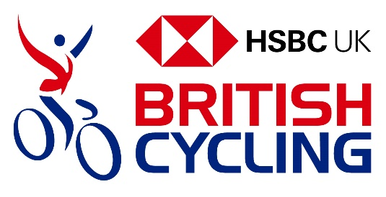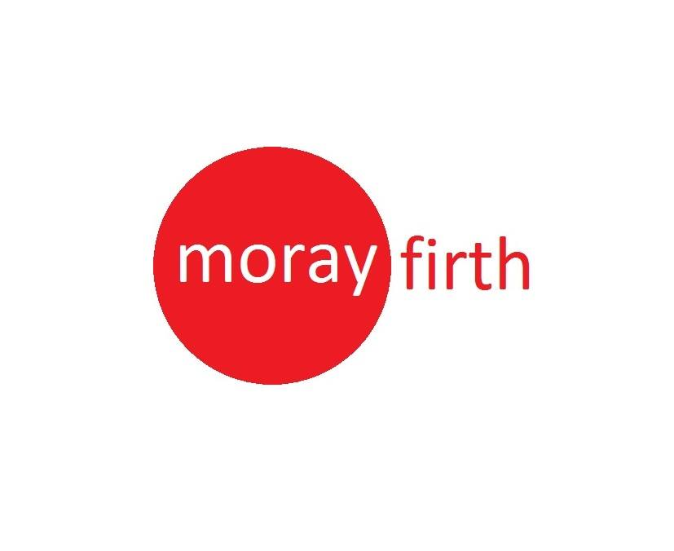

Cycle Coaching (and it’s free!)

Are you interested in improving your :

Road Bike handling techniques?

pedaling, cornering and gear selection?

Group Riding techniques?

Learning in a safe, local environment in a small group with tailored sessions?
- Planning a Sportif or other Road Cycling event in 2023?

When?
It is planned to do the sessions at 9:00 AM on the following Sundays (frost/ice permitting):
12 March
19 March
26 March
2 April
Each session will last 60 minutes, including warm up/cool down. The sessions will be linked and build upon each other. Not the end of the world if you miss one but for best effect great if you can attend all of them. They will be tailored to attendees. Latter sessions may start a bit later depending upon light. Road bikes ideal – if you only have a hybrid please get in touch to discuss.

Where?
Coaching sessions will use the Inverness UHI Main Building (Inshes) tarmac car park for the coaching sessions (marked by big blue cross on map below)- if you ride up head straight to the car park, if you are driving please park in the main gravel visitors car park next to the Reception building.
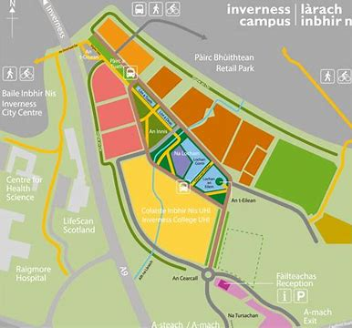

Your Coach
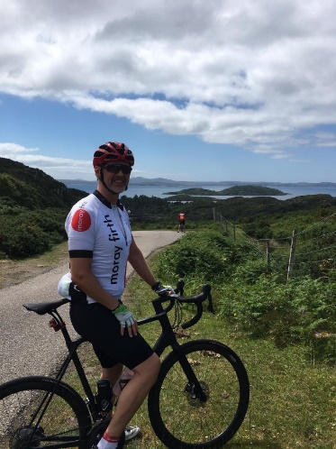
MFCC member and qualified British Cycling L2 coach Andy Cowie, who may be assisted by other coaches availability permitting.

MFCC members prioritized but should be plenty space for non-members too (and we would be delighted if you joined our club).
What Next?
If you’d like to attend please drop Andy an email at coaching@mfcc.org.uk by 3 March (for first session)
These sessions are run under British Cycling regulations/insurance cover so pre-registration is necessary- First come first served. Just one form to fill in for attendees!

